Alex Abraham

Coding Task 1: Complete the sumArray function for calculating the sum of all the array elements.
Coding Task 2: Complete the matrixMultiply function for multiplying two matrices A and B and storing the result in matrix C.
Coding Task 3: Complete the solveQueensUtil function for finding possible solutions for the N queens problem.
Coding Task 4: Complete the bubbleSort and mergeSort functions for sorting values.
Coding Task 5: Complete the numericalIntegration function to approximate the definite integral of a function.
Task 6: Time all five programs (array sum, matrix multiplication, N queens, bubbleSort/mergeSort, and Numerical Integration). Test them using large input values!

This was both a very fun assignment and a very frustrating assignment. I hadn’t kept up with my C++ over the summer and it’s annoyingly similar to C# . I had to look up quite a few instructions on how to to do the things I wanted to do. The first two times earlier this week were total screwups and by the time I got my feet under me, the 6th task felt nearly hopeless. Once everything got set into place, the 6th task kept screwing everything else up. Persistence finds a way.
I assembled the all-tasks menu to make things easier to read.
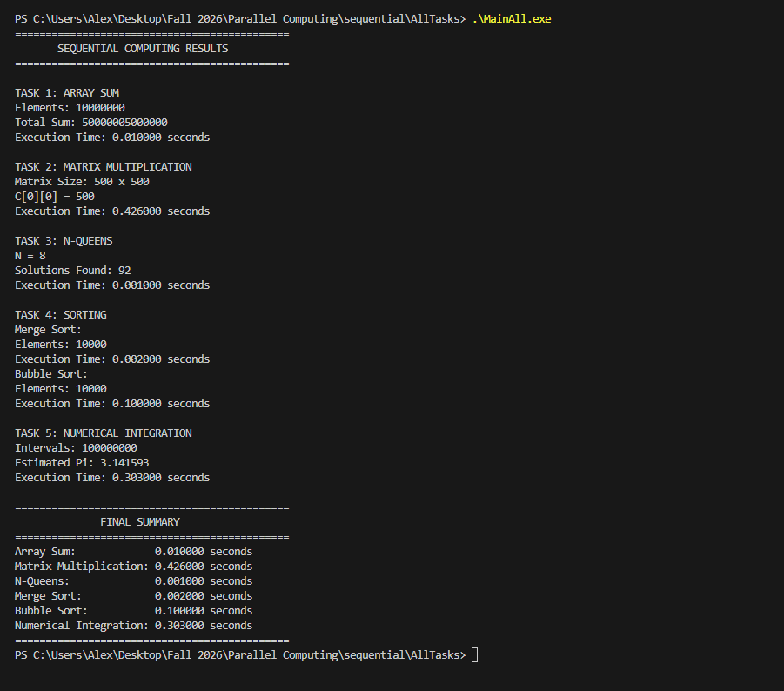

Task 7: Post a discussion in D2L explaining which parts of the five programs could realistically be parallelized and how you would split the tasks for all five programs among different processes. Are there any dependencies that force some parts to remain sequential? Which programs are easy, and which one are hard to parallelize

Working through this process, entertaining pain in the butt that it was, I’d have to say that both the array sums and the multiplication matrixes would be very easy to parallelize. The most important part about parallelizing is that the processes not depend on each other’s work while calculating partial sums. That is very easy to do with addition and multiplication, and you can likewise divide in the same way, because elements of C can be calculated independently.
Merge Sorting would also be relatively easy, because then you could just synchronize numbers during the merge. But…
Maybe I’m new to this, maybe I’m missing some fundamental understanding, but I don’t even know if you COULD parallelize Nqueens or Bubble sort. Maybe someone could explain it to me, because it’s not that hard to visualize addition or multiplication or merging, but I’m having some struggles processing if Bubble Sorting or Nqueens could be parallelized in the first place. They’re a little too dependent on sequential processes. Although, now that I think about it, in different ways.

